Home work -1

Build your own Al assistant for grading a student based on the subjects and a marks entered

Input:

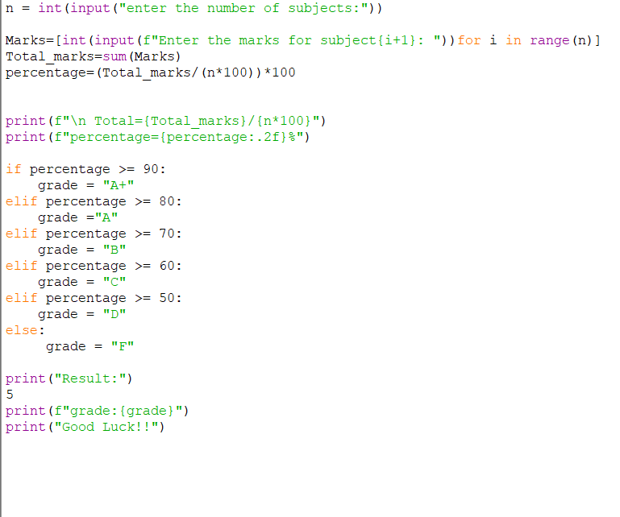

Output:

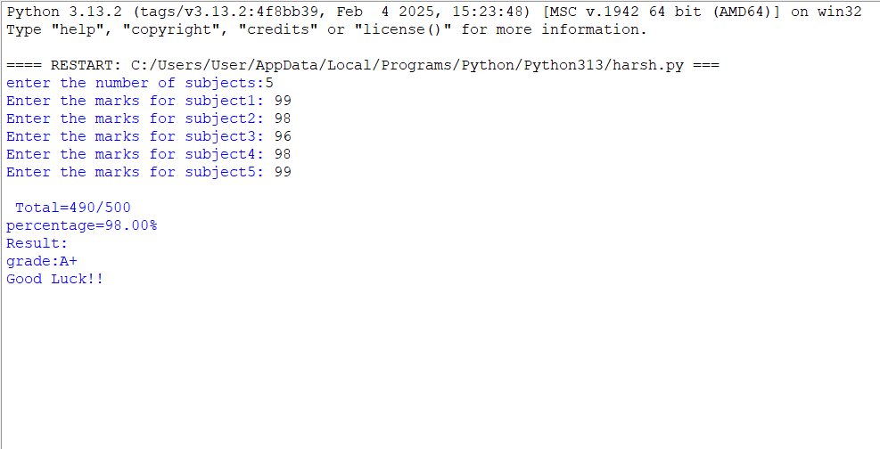

Code:

n = int(input("enter the number of subjects:"))

Marks=[int(input(f"Enter the marks for subject{i+1}: "))for i in range(n)]
Total_marks=sum(Marks)
percentage=(Total_marks/(n*100))*100

print(f"\n Total={Total_marks}/{n*100}")
print(f"percentage={percentage:.2f}%")

if percentage >= 90:
grade = "A+"
elif percentage >= 80:
grade ="A"
elif percentage >= 70:
grade = "B"
elif percentage >= 60:
grade = "C"
elif percentage >= 50:
grade = "D"
else:
grade = "F"

print("~Result")
print(f"grade:{grade}")
print("Good Luck!!")

